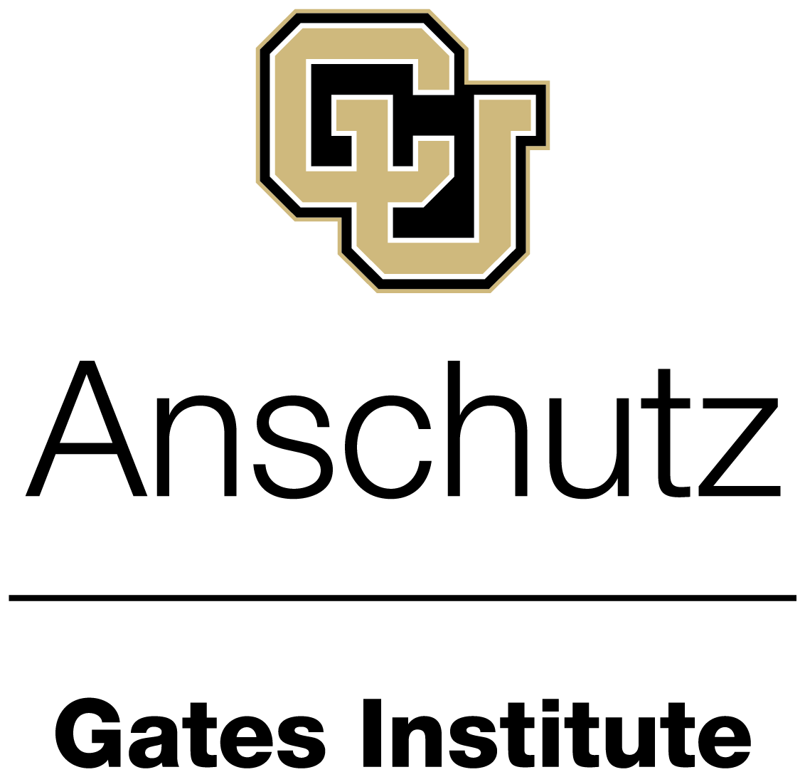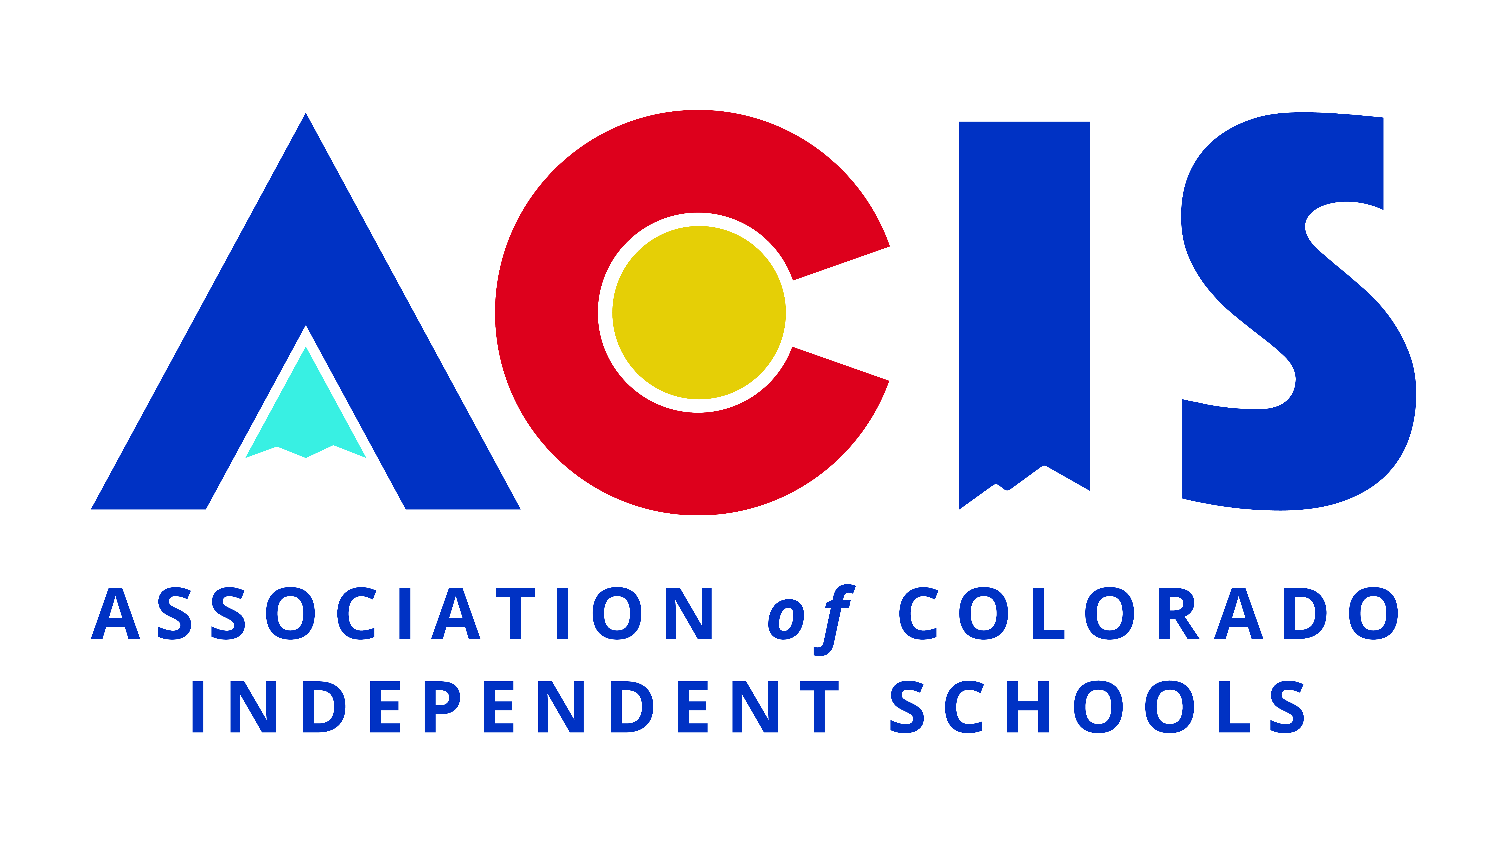

ACIS Science Teachers Visit to the Gates Institute
FROM SCIENTIFIC DISCOVERY TO PATIENT CARE

FRIDAY OCTOBER 9 2026  9:00 a.m. to 1:30 p.m. | ANSCHUTZ HEALTH SCIENCES BUILDING  1890 North Revere Court Aurora Colorado

Cost= $20 per person (includes lunch and parking fees)
Parking= More information regarding parking will be sent to registrants prior to the event.
How does a scientific discovery move from an investigator's laboratory toward a therapy that can be safely studied in patients?
Science teachers from the Association of Colorado Independent Schools are invited to spend a morning at the Gates Institute at the University of Colorado Anschutz exploring the rapidly advancing fields of cell and gene therapy.
The visit will begin with a tour of the CU Anschutz campus, where education, research, clinical care, and innovation come together in a uniquely collaborative environment. Teachers will then receive an introduction to cell and gene therapy and learn how the Gates Institute works to translate laboratory discoveries into regenerative, cellular, and gene therapies that can be manufactured, evaluated, and ultimately delivered to patients.
Participants will visit the laboratory of physician-scientist Eric Kohler, MD, PhD, whose work helped produce the first CAR T-cell therapy developed entirely at CU Anschutz to receive FDA authorization for clinical testing. They will then tour the Gates Institute Translational Sciences Lab and Gates Biomanufacturing Facility to see how promising discoveries are prepared for clinical evaluation.
The program will offer teachers a rare, behind-the-scenes view of the people, facilities, and collaborative processes required to advance a new therapy, as well as perspectives they can share with students considering careers in science and medicine.

Program Schedule

TIME | PROGRAM
9:00 a.m. | Arrival and Welcome  Room 2004, Anschutz Health Sciences Building
9:15–10:15 a.m. | CU Anschutz Campus Tour  Neil Krauss, Assistant Vice Chancellor for Initiatives and Community Engagement
10:30–11:15 a.m. | An Introduction to Cell and Gene Therapy at the Gates Institute  Veena Krishnamoorthy, PhD, Director of Translational Sciences, Gates Institute
11:15–11:45 a.m. | Inside a CAR T-Cell Research Laboratory  M. Eric Kohler, MD, PhD, Assistant Professor of Pediatrics in Hematology, Oncology and Bone Marrow Transplantation
12:00–12:30 p.m. | From Discovery to Clinical Testing  Tour of the Gates Institute Translational Sciences Lab and Gates Biomanufacturing Facility
12:45–1:30 p.m. | Lunch and Conversation

Featured Speakers
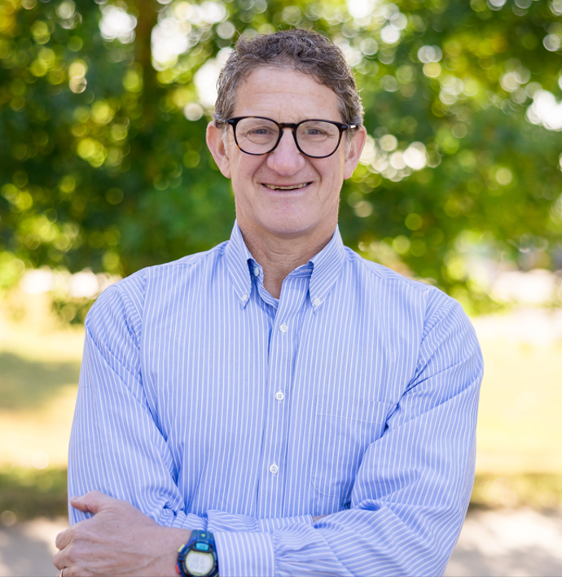 | Neil Krauss  Assistant Vice Chancellor for Initiatives and Community Engagement  University of Colorado Anschutz  Neil Krauss has served CU Anschutz and Chancellor Don Elliman since 2011, helping build connections and collaborations with communities throughout Colorado. His responsibilities include community engagement, educational opportunities for high school and college students, campus events, legislative coordination, and tours introducing visitors to CU Anschutz. Before joining CU Anschutz, Neil held leadership positions at the University of Denver and the University of Colorado. He holds master's degrees in finance and international studies from the University of Denver and a bachelor's degree in journalism from the University of Missouri.

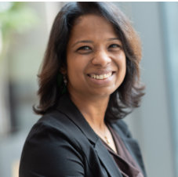 | Veena Krishnamoorthy, PhD  Director of Translational Sciences & Head of Preclinical Development  Gates Institute  Veena Krishnamoorthy leads a team of scientists and researchers working to advance cell therapies for cancer and other diseases. At the Gates Institute, she helps bridge the critical gap between discoveries made in investigators' laboratories and their transition to the Gates Biomanufacturing Facility. She earned her PhD in immunology from the University of Chicago and has more than eight years of experience in the biotechnology industry.

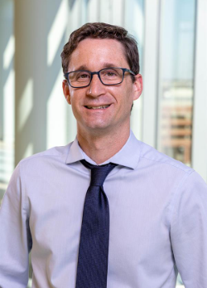 | M. Eric Kohler, MD, PhD  Assistant Professor of Pediatrics in Hematology Oncology and Bone Marrow Transplantation  CU Anschutz School of Medicine and Children's Hospital Colorado  Eric Kohler is a physician-scientist specializing in pediatric hematology, oncology, bone marrow transplantation, and cancer immunotherapy. His laboratory studies how the immune system can be used to treat cancers that do not respond to conventional chemotherapy. This work led to the development of a novel CAR T-cell therapy targeting CD64, a protein found on aggressive leukemia cells. In 2026, the therapy received FDA clearance for clinical testing, becoming the first CAR T-cell therapy developed entirely at CU Anschutz to reach this milestone. His work illustrates the collaborative path through which a scientific discovery can move from the laboratory toward a first-in-human clinical trial.

The Gates Institute and many ACIS member schools
share a history of benefiting from Gates family philanthropy
intended to inspire innovation and advance science.

